# Practical work of IMAS

*“This exercise aims to simulate an efficient manufacturing of gold and silver. There are two kinds of entities: (i) prospectors, that detects where the gold and silver exist, and (ii) diggers that are responsible for collecting the material with gold or silver on it and disposing it into manufacturing centers.”*

## There is a limited grid where the game is running.

## This grid contains cells where can exist any metal (gold or silver).

In the beginning, there is no knowledge about where are the metals so the prospectos must to find them.

Prospectors and diggers will have a visual range surrounding their position (8 cells).

There are manufacturing centers where diggers must leave the metals

Long etc.

## Environment

* **Accesible**: the agent can obtain complete, accurate, up-to-date information about the environment’s state.
* **Deterministic**: any action has a single guaranteed effect — there is no uncertainty about the state that will result from performing an action
* **Episodic**: it does not need to reason about the interactions between different episodes.
* **Dynamic**: during the game a metal could appear into a cell, therefore the environment changes.
* **Discrete:** fixed, finite number of actions and percepts in the environment.

## Agents architecture

*“In conclusion, your design should try to maximise the benefits from excavation”*

* **Deliberative**: focused on long-term planning of actions, centred on a set of basic goals.

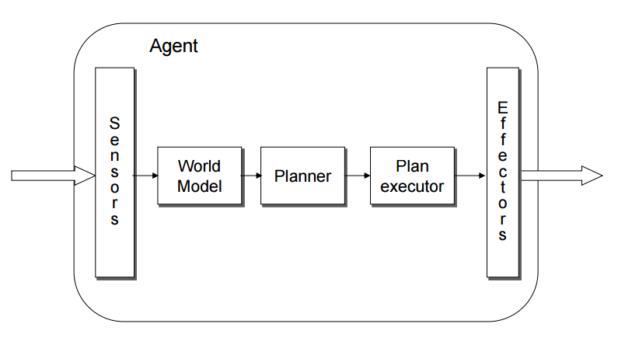

Could be hybrid or other one???

## Agents properties

## Prospector

## 

## Diggers

## Manufacting centers

## System agent

## Coordinator agent